Applying dnn-app-utils-v2 on Jupyter Notebook for image classification
Introduction First a brief introduction to myself. I am taking the deeplearning.ai specialization on coursera.org which requires having knowledge of Python Programming language. I am not an expert in Python programming yet, but I am improving. Having passed the quizzes and carefully organized programming assignments, I applied my newly found knowledge to build an image classifier. This post covers the challenges and experience gained on real world application of knowledge (I just remember a Philosophy class, 'Wisdom is the application of knowledge').
Pre requisites
Download the “Deep Neural Network Application” notebook and “dnn_utils_v2.py” files from the Coursera hub and save them locally. Please enroll in course 1 from the Coursera Deep Learning Specialization. The required material is in the programming assignments from week 4.
You must have gotten the codes for the dnn_app_utils_v2.py correctly in the first programming assignment- Building your NN step by step. The dnn_app_utils_v2.py is a collection of helper functions that are called from our main Python program. Some of the helper functions contained therein are the Sigmoid (), ReLU (), Predict () etc.
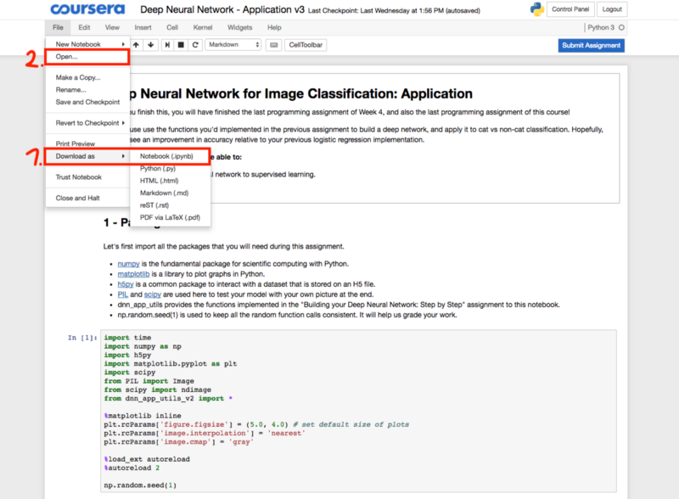
Figure 1: Saving Jupyter notebook

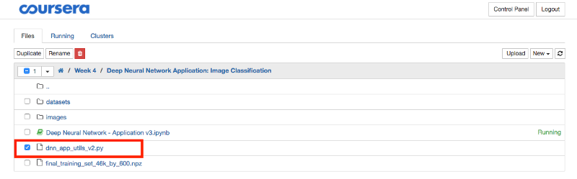
Figure 2: Saving dnn_app_utils_v2.py

Datasets After spending some time reading on creating and preparing datasets from scratch for image classification, the pictures for my datasets were taken from a 5MP phone camera and were about 500. Some of the pictures contain only one person against different but blur backgrounds and some pictures contain more than one person.i.e. 2 or more people. The dimensions of the pictures differ but in the range of 1496*2256 to 2160*3840 pixels, and in jpeg format.
I copied the dataset and saved it in the same folder as my “Deep Neural Network Application” notebook and “dnn_utils_v2.py” files. This made it easy to call the function in my program.

Objective The objective of the algorithm is to train an image classifier for two classes (Binary Classification), where class 1 are pictures with only one image of a person and class 2 are pictures with more than one person.
Methods I manually separated the pictures into 2 folders renamed 'one' and the other folder, 'more'. I moved the pictures accordingly into the folders.i.e. Pictures with one person's image are moved into the 'one' folder and the pictures with more than one images into 'more' folder. I renamed the pictures in 'one' folder to start one and the 'more' folder starts with more.i.e. a picture originally named dsc01.jpg is renamed one (1).jpg’ up to one (n).jpg' where 'n' is the last image in the folder (I use Windows 8.1... it's easily done). This is done to allow me to easily know the index of the pictures when I want to reference them in my code. 200 pictures contained one person’s image therefore put in the 'one' folder and 300 pictures had more than one persons’ images therefore moved to the 'more' folder. My datasets are the pictures(data) in the 'one' and 'more' folders.
I created two folders again, named Train and Test. I copied 140 pictures from 'one' folder to Train folder and the remaining to Test folder. Then 210 pictures from 'more' to Train folder and the rest to Test folder.i.e. I divided my datasets to 70% Train and 30% Test sets Here ends the manual interventions-non programming steps.
After spending some time reading on labelling datasets, labelling is as it is, putting labels on objects, in this case pictures. I opened my “Deep Neural Network Application” notebook and labelled the dataset. See the code on GitHub code on GitHub.
After labelling the dataset, I had to convert the images and reshape them to 64*64 pixels’ size, as advised in the course, for faster processing. (I’m using a CPU based computer). I converted and reshaped each image but forgot to append the converted values to a Python list, I spent couple of days figuring this out. When I forgot to append the processed image to a list of processed images, training the L-layer algorithm pended the cost function to approximately 0.6 after only few iterations (see image below). The reason for the error is, it appears to my algorithm that I was training on a single image repeated in (64*64*3 by m=500) times!!! After appending the images, I reduced my learning rate and removed pictures that might be classified as noisy datasets.
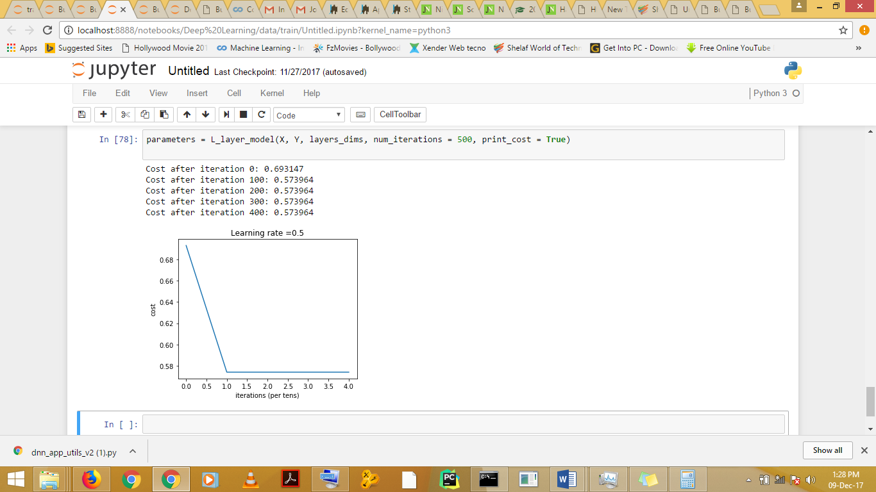
Figure 3: Cost pended at 0.573964 only after 200 iterations

Appending the converted pictures to a list gives an acceptable cost function after about 400 iterations using a 5-layer Neural Network.
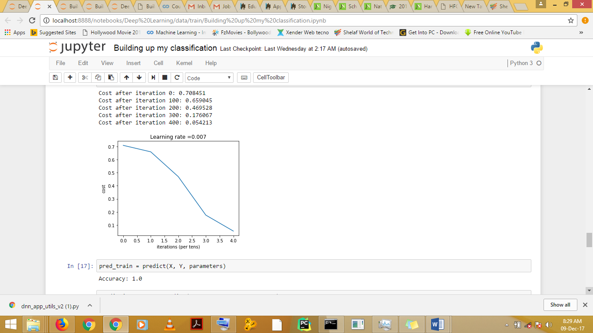
Figure 4: Improved Cost after about 400 iterations

Some of the causes of noisy datasets are, sharpness or blur of image, light intensity, background of images, size of the object in picture. i.e. how far or near camera is to the object in focus.
While there may be better ways of achieving my objective, as a developing Python programmer and ML student, this post highlighted how I applied my new found knowledge to real life image classification challenge.
This is my first post here, please scrutinize, advice and improve.
Visit my GitHub repository for the code.
Happy learning!!!

P.S: I was motivated by this post, as soon as I read the post I concluded doing this NOW!!!

